Practical No.2

Q.1Develop an list components
import java.awt.*;
import java.applet.Applet;

/**
*
* @author DELL
*/
public class NewApplet extends Applet {

/**
* Initialization method that will be called after the applet is loaded into
* the browser.
*/
public void init() {
// TODO start asynchronous download of heavy resources
List l = new List (6);
l.add("karad");
l.add("vita");
l.add("pune");
l.add("mumbai");
l.add("kholapur");
l.add("sangli");
add(l);

}

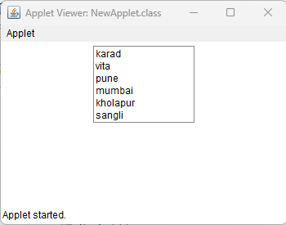

Q2.
import java .awt.*;
import java.applet.Applet;

/**
*<applet code = "choice_1" width=200 height=50>
* </applet>
* @author DELL
*/
public class choice_1 extends Applet {

/**
* Initialization method that will be called after the applet is loaded into
* the browser.
*/
public void init() {
// TODO start asynchronous download of heavy resources
Choice ch = new Choice();
ch.add("lokamat");
ch.add("sakal");
ch.add("pudhari");
add(ch);

}

// TODO overwrite start(), stop() and destroy() methods
}

